Adding Logos to an Epicor Report

# Background

Some standard reports already have been built to use images from the Epicor Image gallery in Kinetic. The list of reports can be found in  [KB0050698](https://epiccare.epicor.com/kb_view.do?sys_kb_id=7fd3bda6971c06d474a83a121153af36&sysparm_rank=1&sysparm_tsqueryId=f26f05df471c2a10090ebb7c026d431d) on EpicCare, these being:

* Packing Slip
* Purchase Order
* Sales Order Acknowledgement
* AR Invoice
* Customer Statements
* Supplier Statements
* Reminder Letter
* Debit Memo

**Important note**: Logos are company specific. To add a logo to a report style for a specific company you need to be logged into the specific company at the time to add the correct logo.

## How to add a logo

To add logo functionality onto additional reports the following steps need to be performed.

1. If the Logo does not exist in the image gallery, use Image Maintenance to import the image. Images are company specific. You must import the image into the specific company/report style you with the Logo to appear on.
2. Take an existing RDL that has the logo functionality and copy the ReportImages Dataset identically to the RDL of the report you wish to add the logo to.
3. Copy the Image object from the source rdl to the destination rdl
4. Upload the modified RDL to the related report style
5. Click on the company/images tab
6. Select the current company from the company list
7. Click on the retrieve button to display the logo entry
8. Double click on the empty image preview cell. This will open up the image search
9. Search for and select the image required. (note the image needs to be imported prior to searching)
10. Save the Report Style
11. Test the report
12. A good indication things are configured correctly is that in the Reporting database there will be a new table dbo.ReportImages_ with the GUID of the executed report. And the logo will appear on the report.

## Steps with images. (Classic)

Add your logo. If the logo has already been added then it does not need to be added again, unless you are adding logos for a different company.

Figure . Open Image Maintenance

Figure . Image Maintenance opened.

Figure . Add new Image. Provide name and Image Category (Optional), click browse

Figure . Select Image file

Figure . Selected Image file loaded, Save and Exit

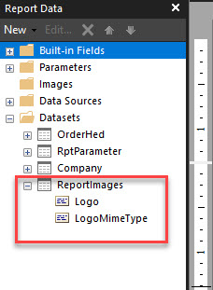

Figure . Example ReportImages dataset from OrderAck

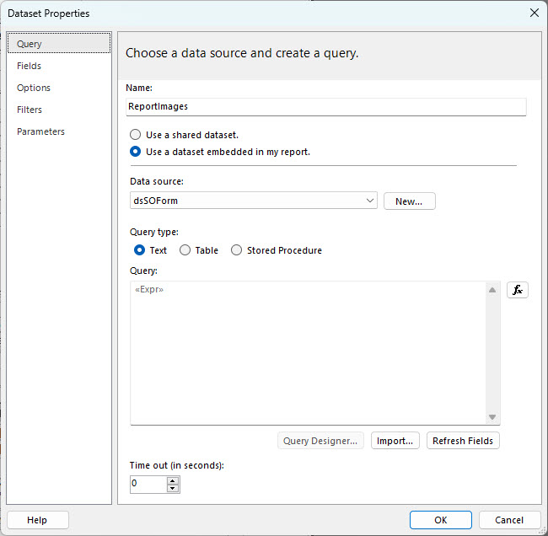

Figure Source RDL Dataset Properties

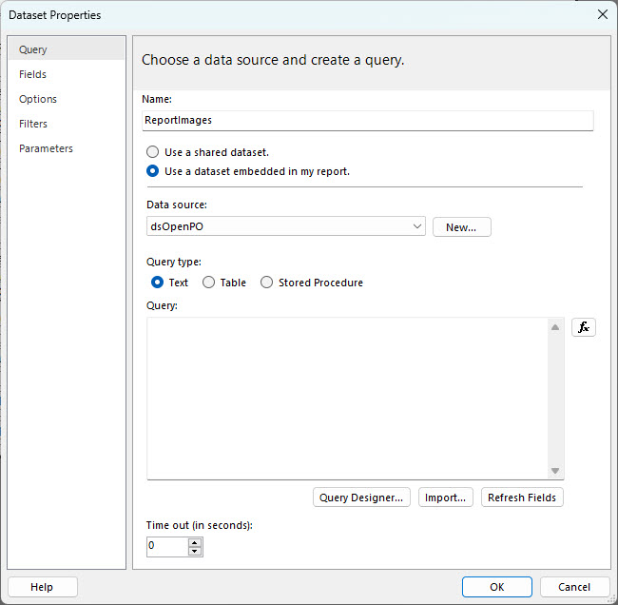

Figure New DataSet Properties in destination RDL

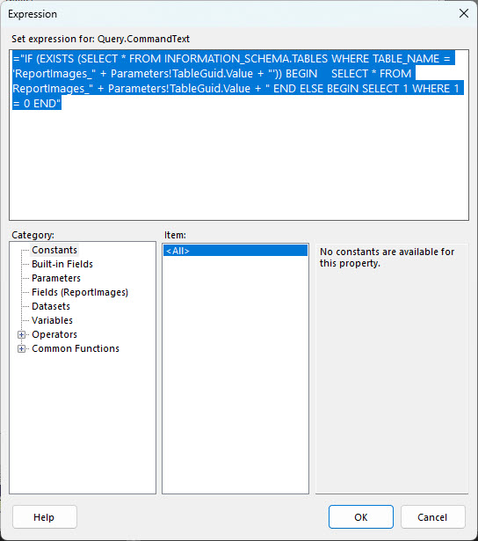

Figure . copy the Expression from the Source RDL Dataset to the Destination RDL

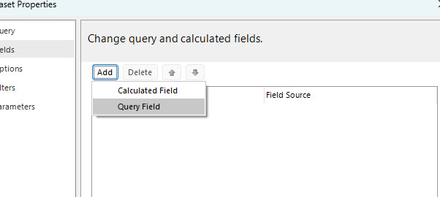

Figure Add the Logo and LogoMimeType fields

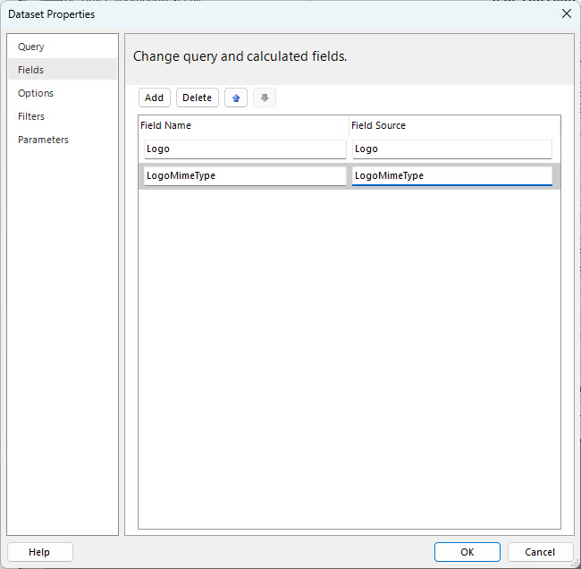

Figure Newly created Query Fields

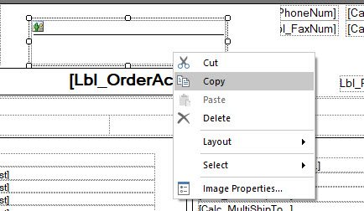

Figure . Copy the Image Object from Source RDL

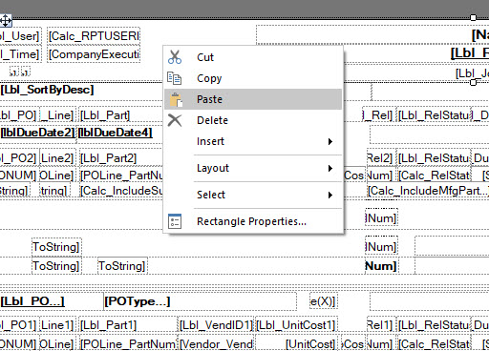

Figure . Paste the Image Object to the Destination RDL

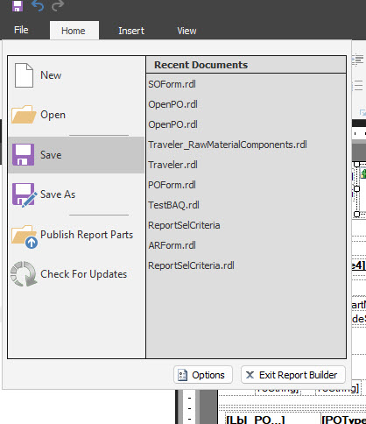

Figure . Save the RDL

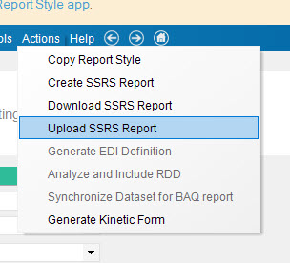

Figure . Upload the RDL to the report style.

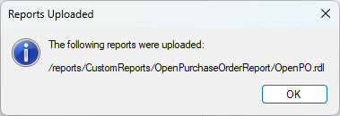

Figure . RDL Uploaded.

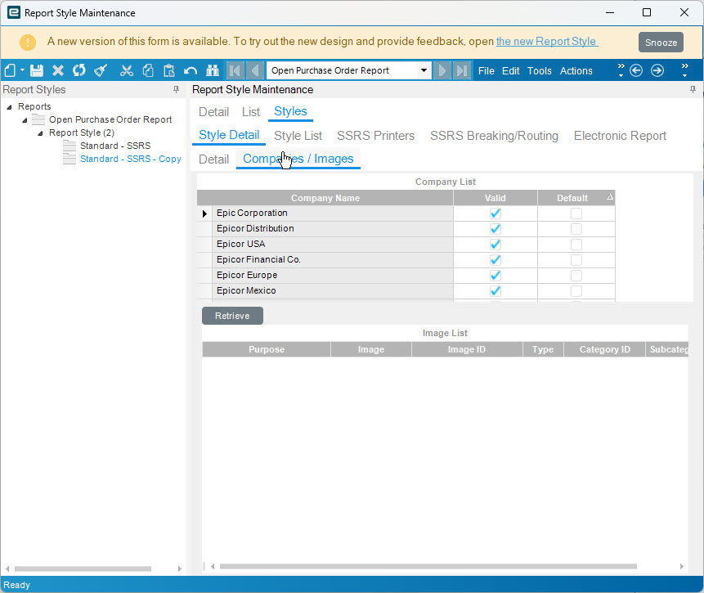

Figure . In the Report Style, Select the report style, click on Companies/Images. Select the currently logged in company. Click on Retrieve.

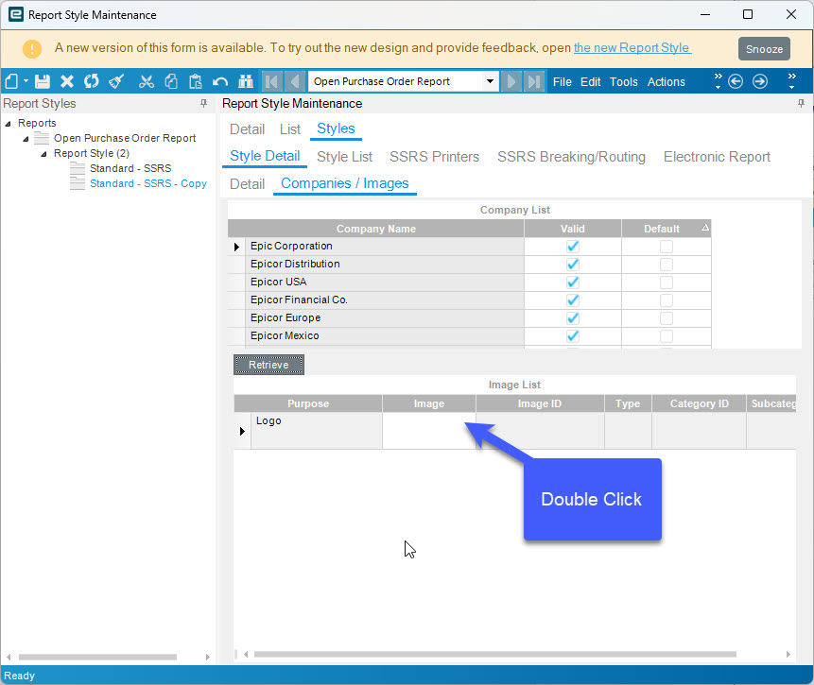

Figure . Double click on the empty image cell

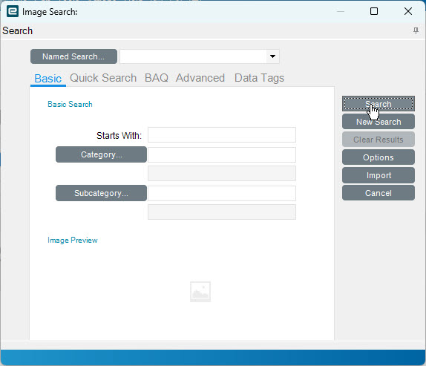

Figure . Image Search appears.

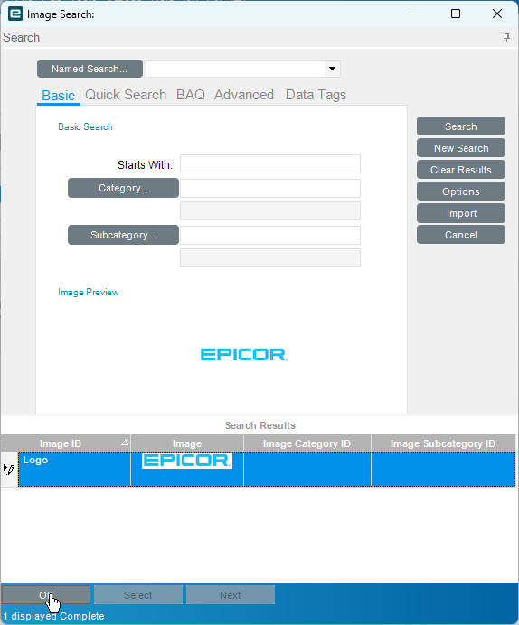

Figure . Select the Logo image.

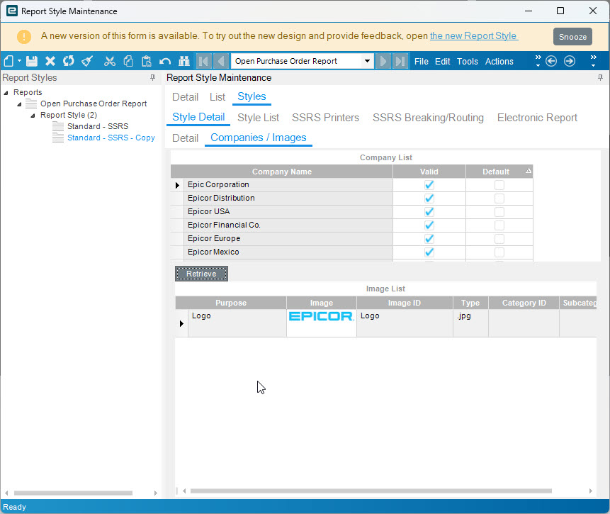

Figure . Image should appear in the Image Cell. Save the Report Style

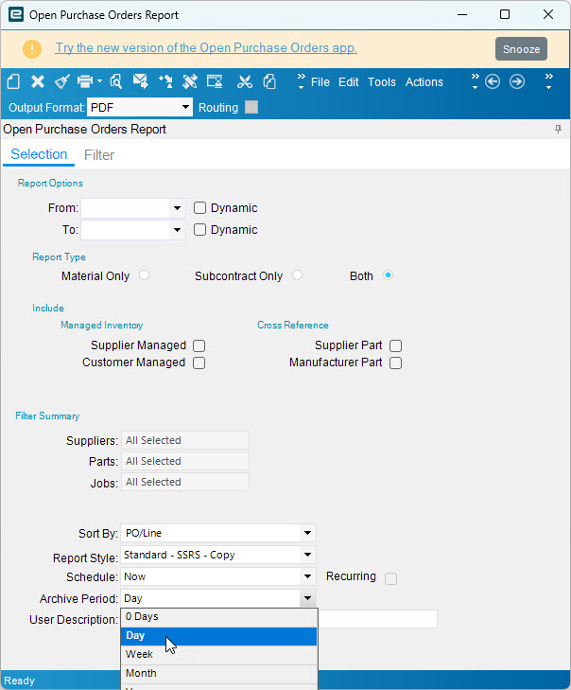

Figure . Run the report to test, ensure the correct style and the archive period is set.

Figure . If you are On-Prem and you have access to the Reports Database you will see the ReportImages table created

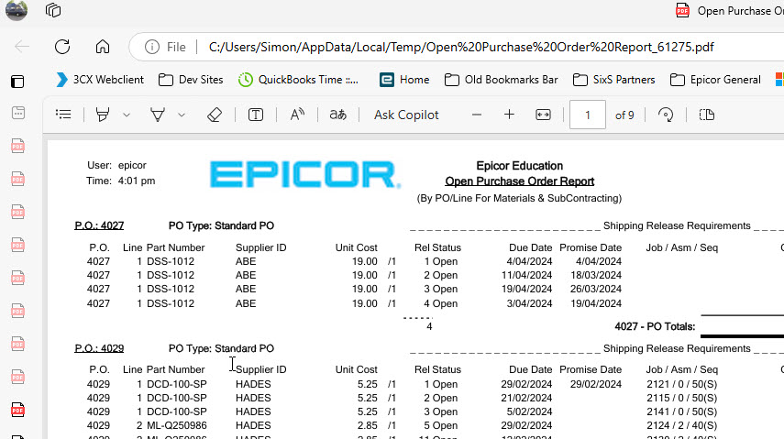

Figure . Example of updated report with logo.

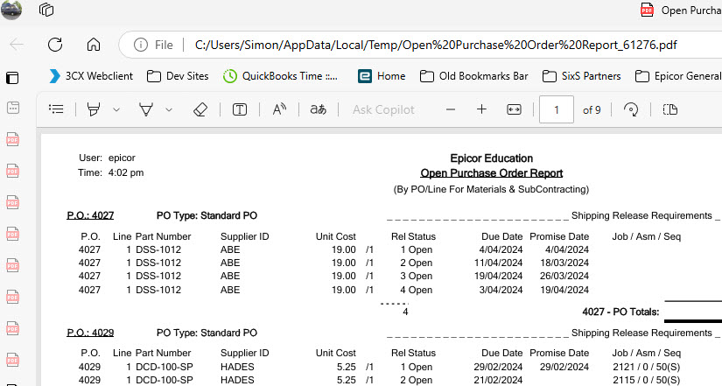

Figure Example of Original report with no logo.

## Steps with images (Kinetic)

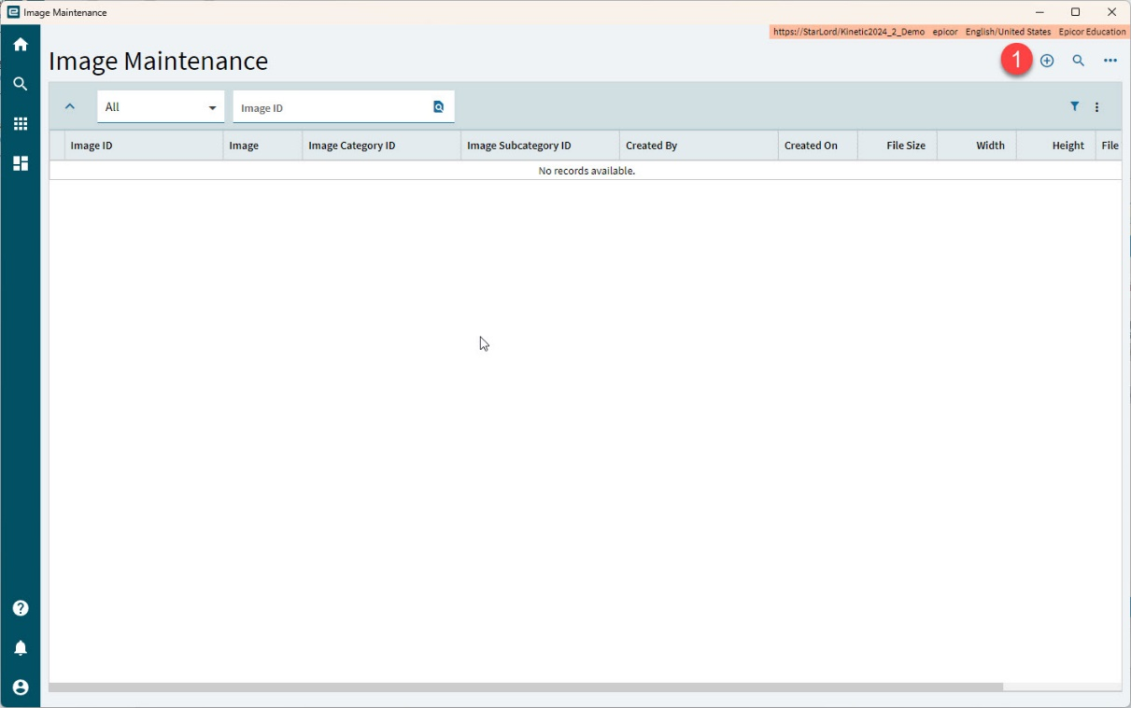

Figure . Open Image Maintenance

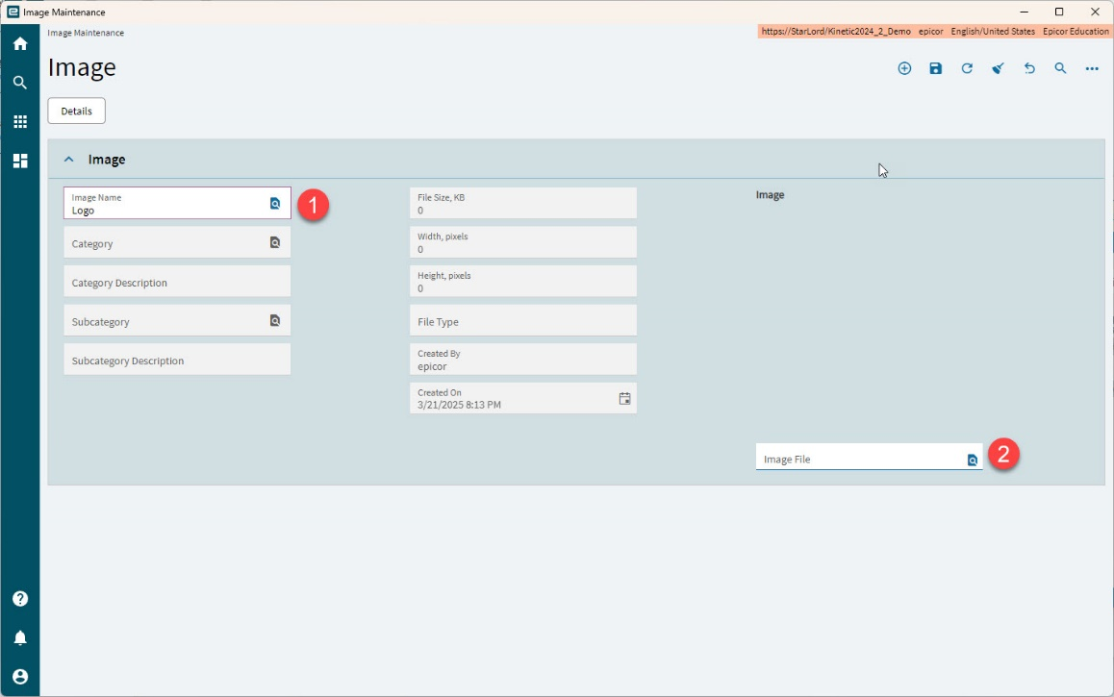

Figure . Enter the Image Name, and search for the image file to add

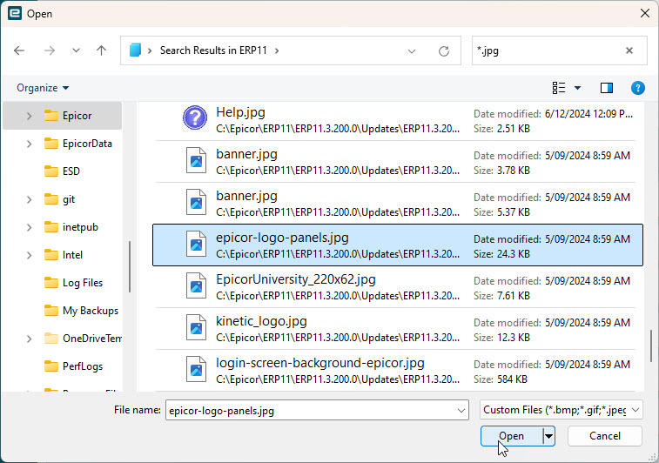

Figure . Select File.

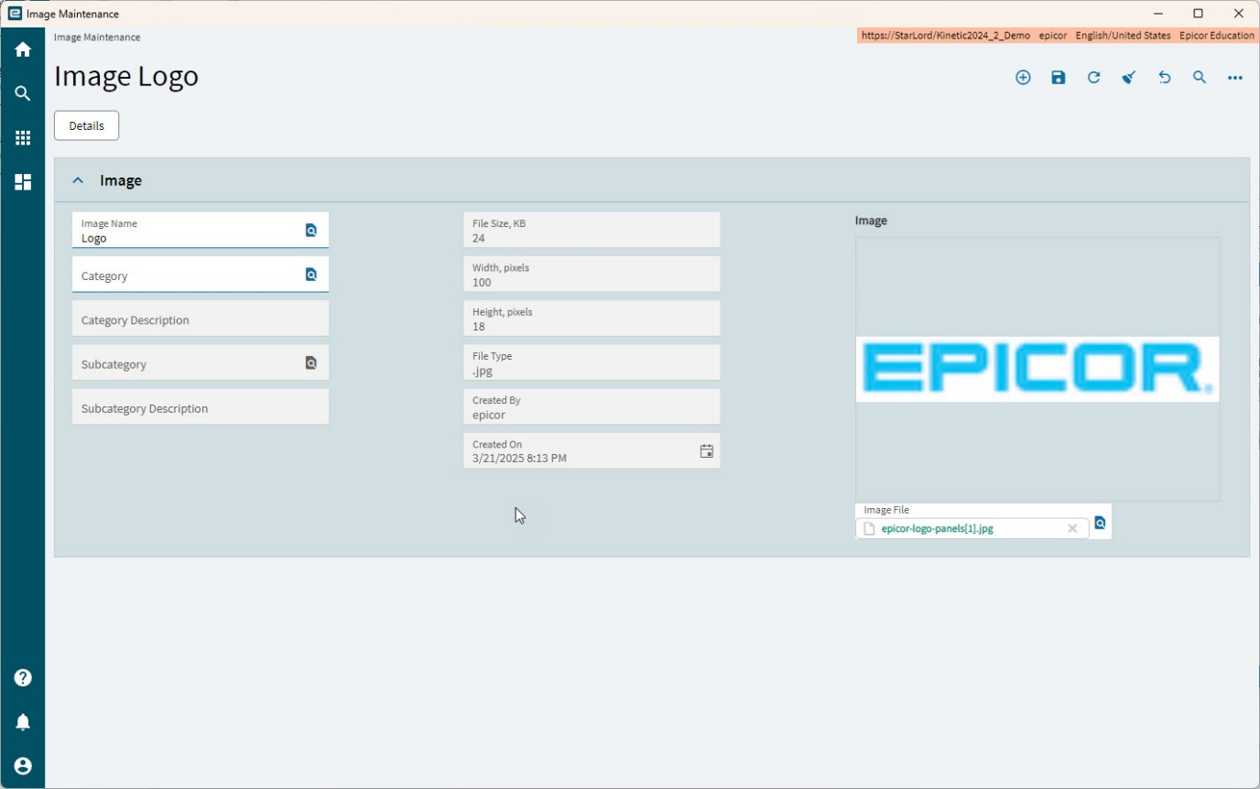

Figure . Image Added

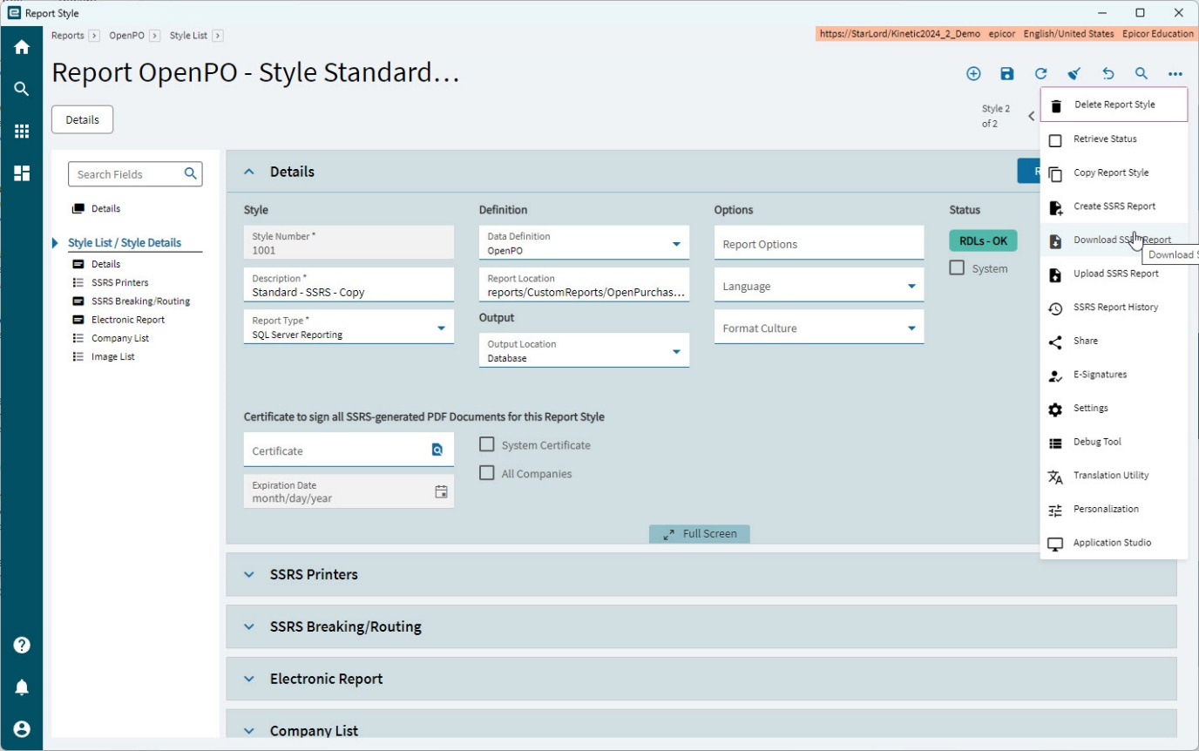

Figure . Open the report style to add the logo to and download the RDL

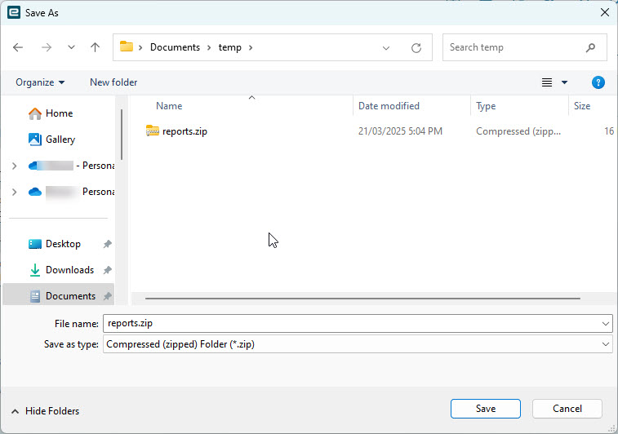

Figure . Select a location to store the Zip file

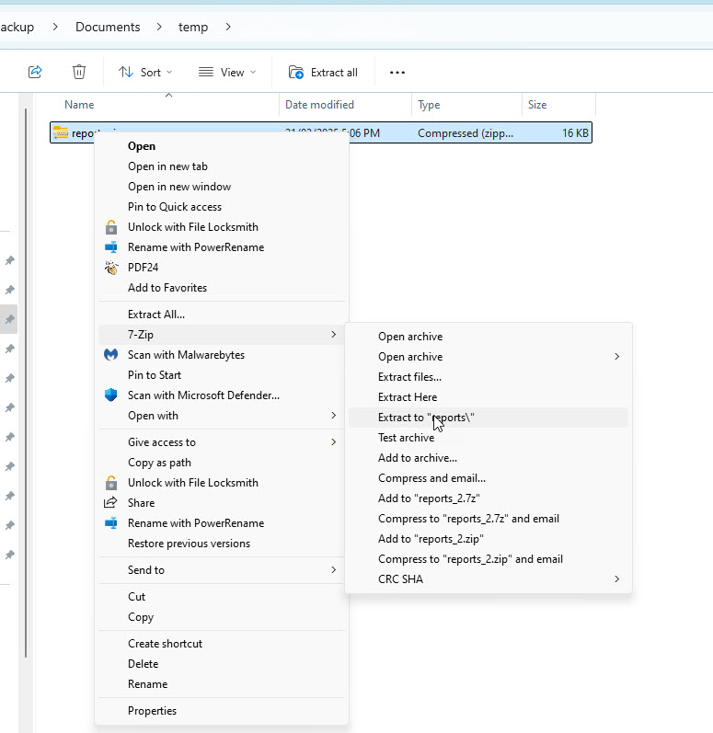

Figure . Extract the zip file to an appropriate location, keep the folder structure. Using 7Zip here, if using standard windows extract all pay close attention to the path.

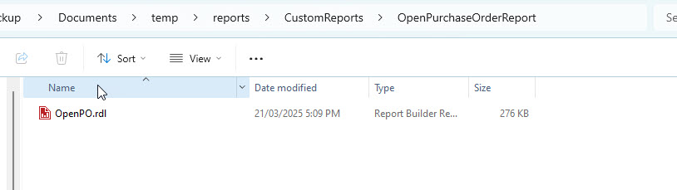

Figure . Modify the RDL in the same way as in the Classic instructions.

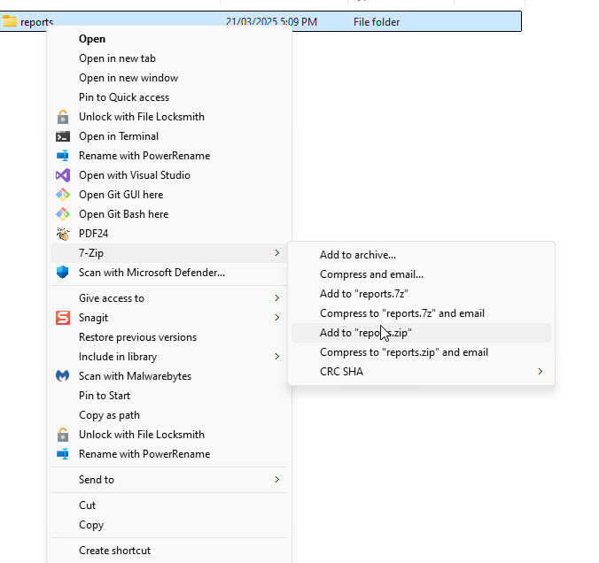

Figure . Zip the reports folder up again ensuring to maintain the folder structure. Epicor expects the Zip file to have the same relative path as in the SSRS report server folder structure.

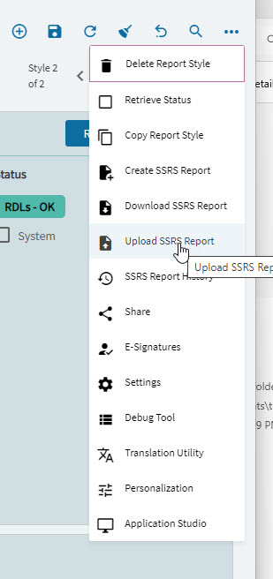

Figure . Upload the RDL file

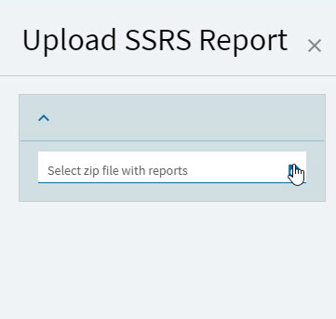

Figure . Reports.zip file that you just created

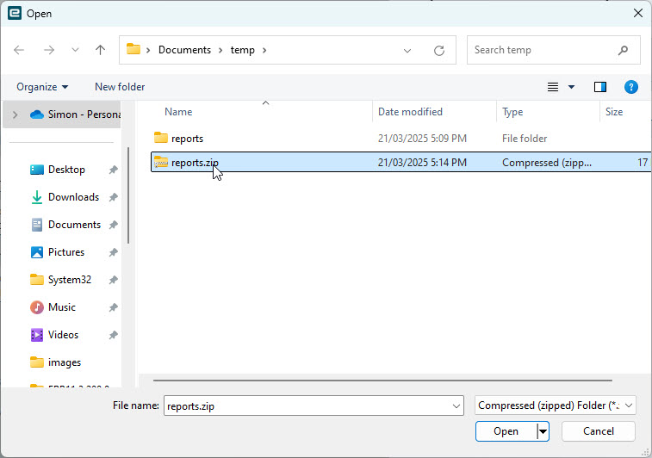

Figure . Example reports.zip

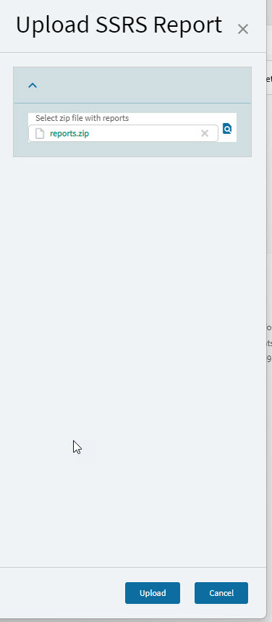

Figure . Click Upload

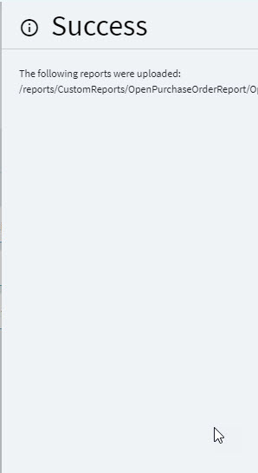

Figure . If all things have uploaded correctly, you will receive a success notification.

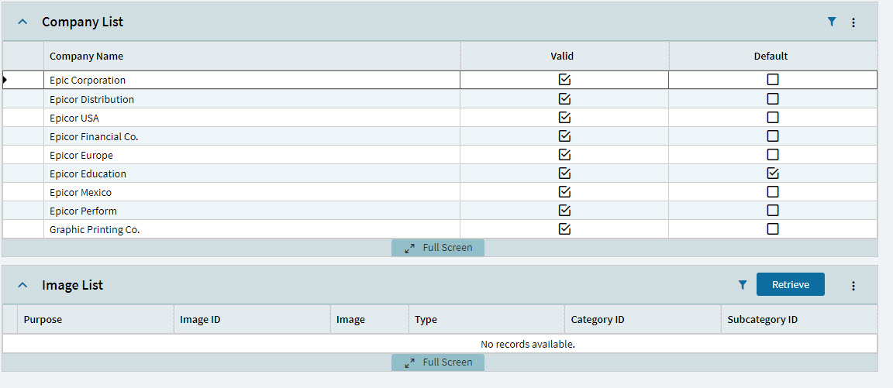

Figure . In the report style Click the current company in the company list.

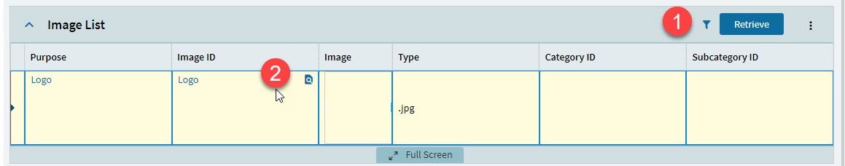

Figure . In the Image List Panel card click "Retrieve", then the search icon in the Image ID cell.

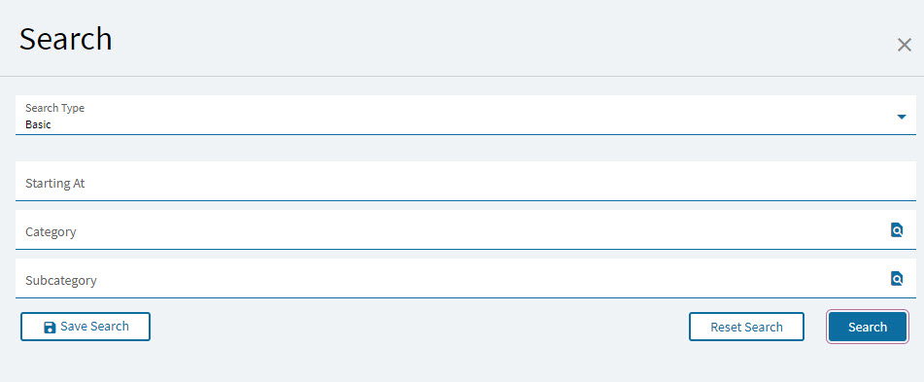

Figure . Image Seach dialog appears.

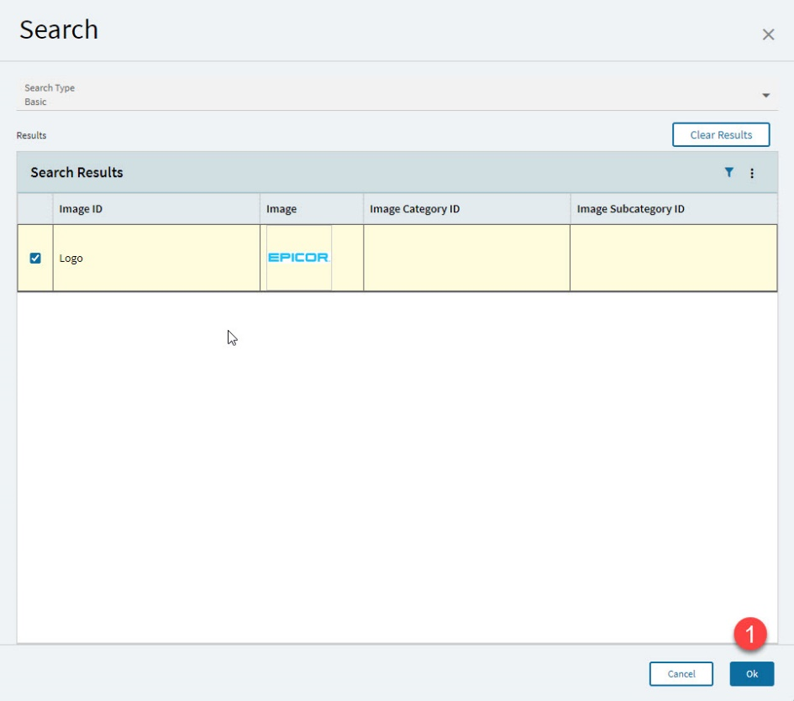

Figure . Select the image to use and click Ok.

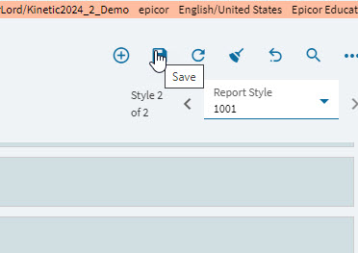

Figure . Save the report style.

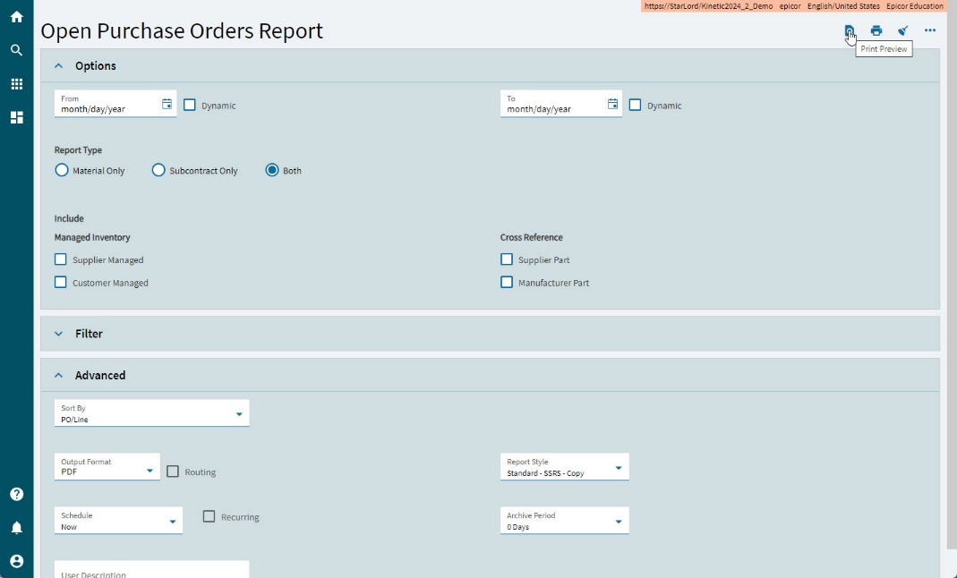

Figure . Open the related print App for the report style you modified. Select the relevant report style and any other parameters. Click Preview

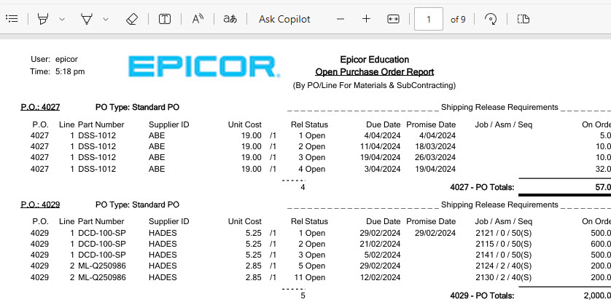

Figure . Review the results of your work.